# EXERCISE - 9: 3-DIMENSIONAL PROJECTIONS IN C++ USING OPENGL

**AIM:**

Write a menu driven program to perform Orthographic parallel projection and Perspective projection on any 3D object.

Set the camera to any position on the 3D space. Have (0,0,0) at the center of the screen. Draw X, Y and Z axis.

You can use gluPerspective() to perform perspective projection. Use keyboard functions to rotate and show different views of the object. [Can use built-in functions for 3D transformations].

# ALGORITHM:

1. Initialise frame buffer using glutInit()
2. Set display mode as single buffer for 2D graphics with RGB colour using glutInitDisplayMode()
3. Set output window size as 640, 640 pixels using glutWindowSize()
4. Create the output window using glutCreateWindow()
5. Call function to draw using glutDisplayFunc()
6. Set visibility of faces using depth test parameter using glEnable()
7. In the display function
   1. Set background colour (RGB, opacity) as white using glClear()
   2. Clear frame buffer using glClear()
   3. Set matrix mode to manipulate matrix values using glMatrixMode()
   4. Load identity matrix using glLoadIdentity()
   5. Set camera position
   6. Plot coordinate axis
   7. Draw the object
   8. Get the key input and adjust the rotation and translation values.
   9. Use gluOrtho() and gluPerspective() for orthographic and perspective projections respectively.
   10. Display the object
   11. End using glEnd()
   12. Flush frame buffer using glFlush()
8. Refresh the screen repeatedly while calling the function to draw using glutMainLoop()

# CODE:

#include <GL/glut.h>

// Projection mode (0 for Orthographic, 1 for Perspective) int projectionMode = 0;

// Rotation angles float rotateX = 0.0f; float rotateY = 0.0f;

// Camera position float cameraX = 0.0f; float cameraY = 0.0f; float cameraZ = 5.0f;

// Function to draw the 3D object void draw3DObject() {

// Replace this with your 3D object drawing code

//glutSolidCube(1.0);

glBegin(GL_TRIANGLES); glColor3f(0.682, 0.871, 0.988);

glVertex3f(0, 1, 0);

glVertex3f(-1, 0, -1);

glVertex3f(1, 0, -1);

glColor3f(1, 0.984, 0.451);

glVertex3f(0, 1, 0);

glVertex3f(1, 0, -1);

glVertex3f(1, 0, 1);

glColor3f(0.694, 0.369, 1);

glVertex3f(0, 1, 0);

glVertex3f(1, 0, 1);

glVertex3f(-1, 0, 1);

glColor3f(0.972, 0.459, 0.667);

glVertex3f(0, 1, 0);

glVertex3f(-1, 0, 1);

glVertex3f(-1, 0, -1);

glEnd();

glColor3f(0.914, 0.722, 0.141);

glBegin(GL_QUADS); glVertex3f(-1, 0, -1);

glVertex3f(1, 0, -1);

glVertex3f(-1, 0, 1);

glVertex3f(-1, 0, -1); glEnd();

//Vertices

glColor3f(1.0, 1.0, 1.0); glBegin(GL_LINES); glVertex3f(0, 1, 0);

glVertex3f(-1, 0, -1);

|  |  |  |
| --- | --- | --- |
| glVertex3f(0, | 1, | 0); |
| glVertex3f(1, | 0, | -1); |
| glVertex3f(0, | 1, | 0); |
| glVertex3f(1, | 0, | 1); |
| glVertex3f(0, | 1, | 0); |

glVertex3f(-1, 0, 1);

glVertex3f(-1, 0, -1);

|  |  |  |
| --- | --- | --- |
| glVertex3f(1, | 0, | -1); |
| glVertex3f(1, | 0, | -1); |
| glVertex3f(1, | 0, | 1); |
| glVertex3f(1, | 0, | 1); |
| glVertex3f(-1, | 0, | 1); |
| glVertex3f(-1, | 0, | -1); |
| glVertex3f(-1,  glEnd(); | 0, | 1); |

}

// Function to set up the perspective projection void setPerspectiveProjection() {

glMatrixMode(GL_PROJECTION); glLoadIdentity();

gluPerspective(45.0, 1.0, 1.0, 100.0); glMatrixMode(GL_MODELVIEW);

}

// Function to set up the orthographic projection void setOrthographicProjection() {

glMatrixMode(GL_PROJECTION); glLoadIdentity();

glOrtho(-2.0, 2.0, -2.0, 2.0, 1.0, 100.0);

glMatrixMode(GL_MODELVIEW);

}

// Display function void display() {

glClearColor(1.0, 1.0, 1.0, 0.0); glClear(GL_COLOR_BUFFER_BIT | GL_DEPTH_BUFFER_BIT);

glLoadIdentity();

// Set camera position and look at (0, 0, 0) gluLookAt(cameraX, cameraY, cameraZ, 0, 0, 0, 0, 1, 0);

// Apply rotation

glRotatef(rotateX, 1.0f, 0.0f, 0.0f); glRotatef(rotateY, 0.0f, 1.0f, 0.0f);

// Draw X, Y, and Z axes

glBegin(GL_LINES); glColor3f(1.0f, 0.0f, 0.0f);

glVertex3f(-2, 0, 0);

glVertex3f(2, 0, 0);

glColor3f(0.0f, 1.0f, 0.0f);

glVertex3f(0, -2, 0);

glVertex3f(0, 2, 0);

glColor3f(0.0f, 0.0f, 1.0f);

glVertex3f(0, 0, -2);

glVertex3f(0, 0, 2); glEnd();

// Draw the 3D object

glColor3f(1.0f, 1.0f, 1.0f); // White object draw3DObject();

glutSwapBuffers();

}

// Keyboard function to handle menu-driven options void keyboard(unsigned char key, int x, int y) {

switch (key) { case 'o':

projectionMode = 0; // Switch to Orthographic projection setOrthographicProjection();

break; case 'p':

projectionMode = 1; // Switch to Perspective projection setPerspectiveProjection();

break; case 'r':

rotateX += 10.0f; // Rotate object break;

case 'l':

rotateY += 10.0f; // Rotate object break;

case 'f':

cameraZ -= 0.25f; // Move camera forward break;

case 'b':

cameraZ += 0.25f; // Move camera backward break;

case 27: // ESC key to exit exit(0);

}

glutPostRedisplay();

}

int main(int argc, char** argv) { glutInit(&argc, argv);

glutInitDisplayMode(GLUT_DOUBLE | GLUT_RGB | GLUT_DEPTH); glutInitWindowSize(800, 600);

glutCreateWindow("3D Projection");

glEnable(GL_DEPTH_TEST); glutDisplayFunc(display); glutKeyboardFunc(keyboard);

setOrthographicProjection(); // Initial projection mode glutMainLoop();

return 0;

}

# OUTPUT:

**Orthographic Projection Perspective Projection**

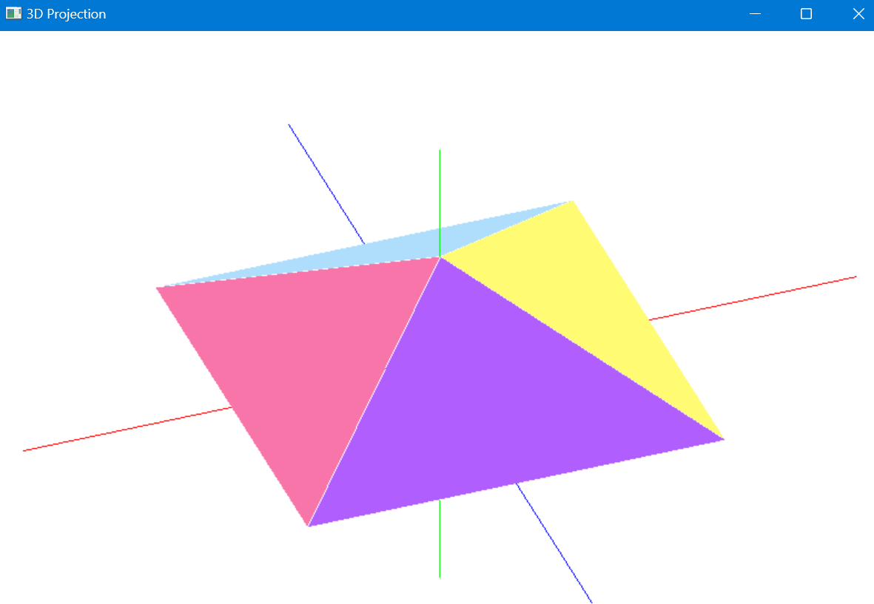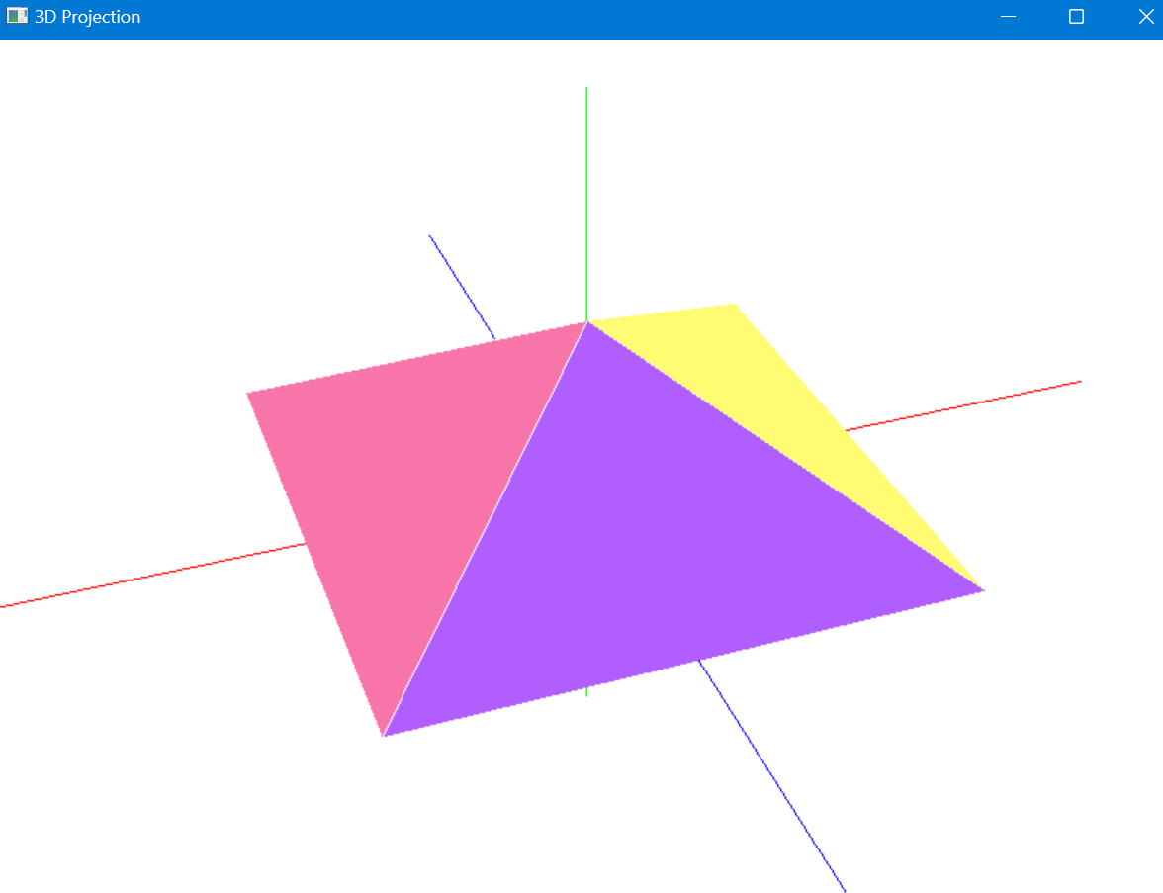

**Moving Camera Forward Moving Camera Backward**

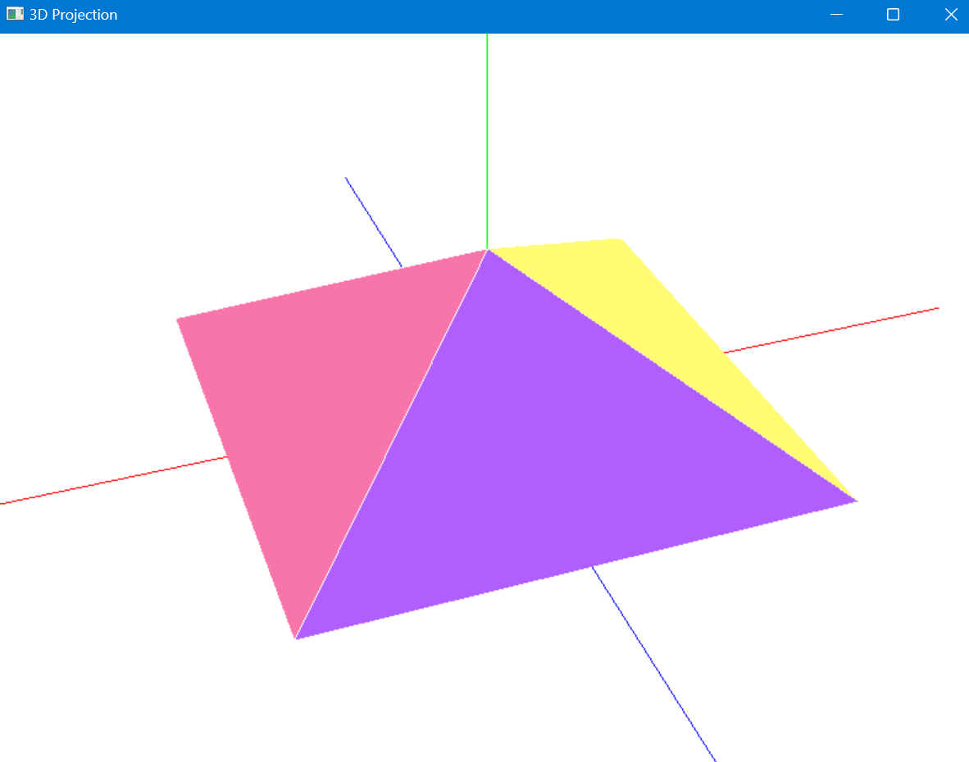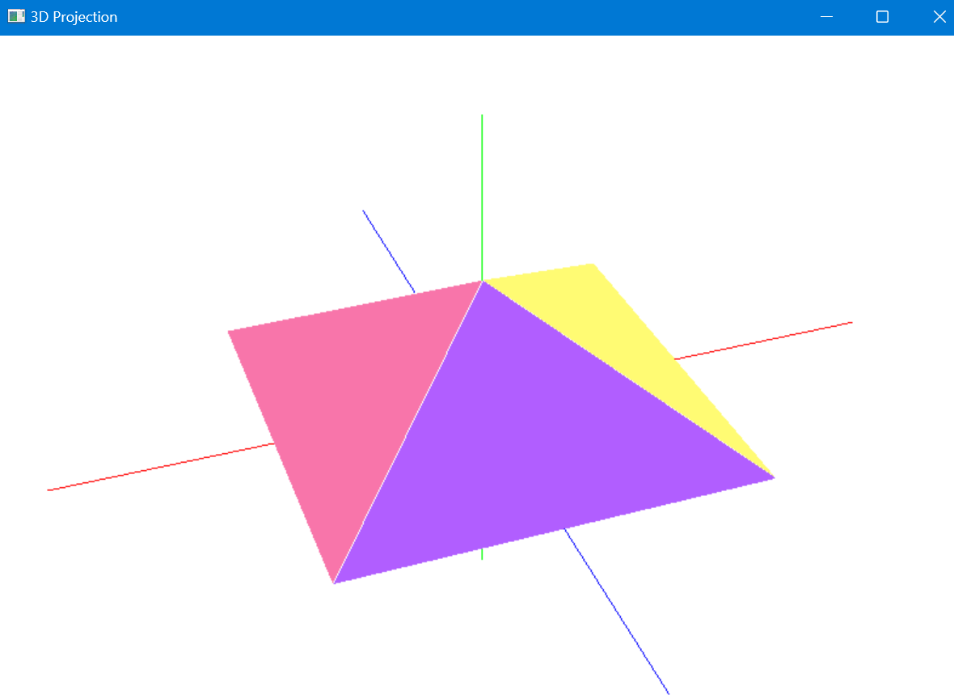

**Rotate Right Rotate Left**

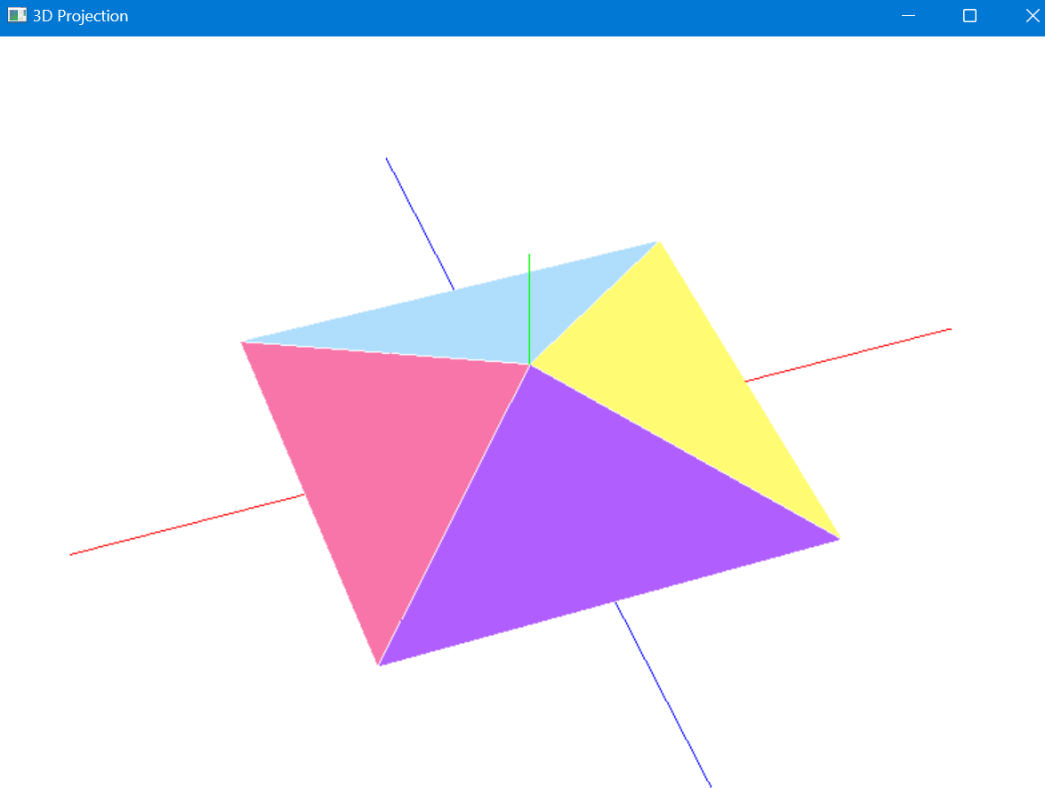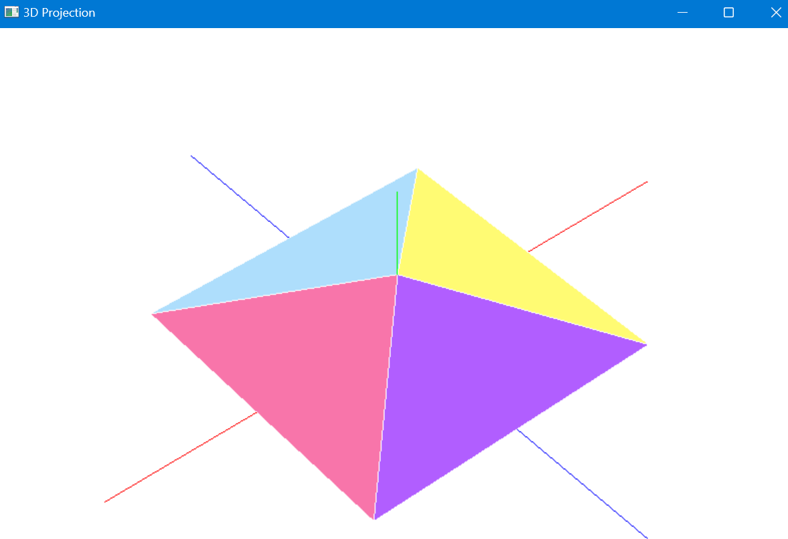

# LEARNING OUTCOMES:

1. Learnt to adjust the parameters of the frames
2. Learnt to plot points and mark coordinates
3. Learnt to plot points in 3-Dimensions
4. Learnt about parallel and perspective projections